42U ENCLOSURE 19" CABINET 600X600 FLOOR STANDING DATA RACK - VALUCAB
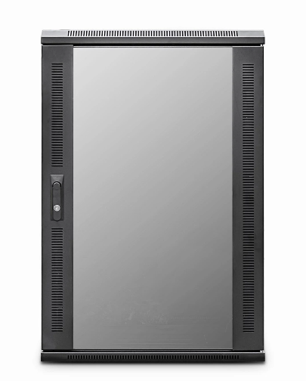

DESCRIPTION

The LMS Data EcoNetCab is the defacto standard in offering great choice and quality enclosure solutions, be it structured cabling for your copper or fibre networking, LAN or WAN networking deployment or broadcast A/V for companies of all sizes. Designed for the installer and IT manager, all enclosure come with useful features to make your installation that much easier, together with bundled free accessories you need to get your new installation up and running.

SPECIFICATIONS
42U high 600W 600D
• 19" standard
• Colour: Black (Powder-coated RAL 9005)
• Dimensions: 600 (width) x600(depth) x2050mm (height - inc. castors)
• Front tempered glass door (lockable)
• Left/right hinged front/rear doors
• Removable side panels for easy access
• U-numbered uprights for rack-mount product alignment
• Multiple cable entry glands for exact power and cabling entry

TECHNICAL INFO
SKU/MNP: CAB-FE-42U-66NA
EAN: 8400800031235
Dimensions: 600 (width) x600(depth) x2050mm (height - inc. castors)

SUPPLIED WITH
Standard/Shipping Castors (Fitted): Set of 4 adjustable Jacking Feet (Supplied): Standard M6 Cage Nuts and Bolts (Supplied): Hex Adjusting Key (Supplied)

FILES
﻿Specification Sheet (PDF)

